**Lecture -01**

**Peripheral:** The devices that are external to the main processing function of the computer. Peripheral devices can be classified as input, output and storage devices.

**Interfacing:** An interfacing is the point of interaction with software, computer hardware or with peripheral devices. There are two types of interfaces, Hardware interface and Software interface.

Basically peripheral devices are connected to the computer via Interfacing. For example we use pendrive to carry a soft copy of a file. We connect the pendrive with our computer via USB-port. Here the pendrive is a peripheral device and the USB-port is the point of interaction or we can say interfacing point.

**Hardware Interface:** Hardware interfaces exist in computing systems between many of the components such as the various buses, storage devices, I/O devices. A hardware interface specifies the plugs, sockets, cables and electrical signals that pass through each line between the CPU and a peripheral devices or communications network. For example USB, FireWire, Ethernet, IDE, SCSI and PCI.

**Software Interface:** A software interface may refer to a range of different types of interface at different levels.

**Physical Port:** Physical ports are used for connecting a computer through a cable and a socket to a peripheral device. For example Serial ports, USB ports. Parallel ports.

**Virtual Port:** Virtual ports are data gates that allow software applications to use hardware resources without any interference. Those are used in TCP and UDP to identify unique end-to-end connections. for example google drive, HTTP, HTTPS, NTP.

**Serial Port:** Serial port is a serial communication interface through which information transfers in or out sequentially one bit at a time. for example DB-9 connector,

**Parallel Port:** A parallel port is a type of interface found in early computers for connecting peripheral devices. For example- DB-25, Display port, VGA port, HDD port etc.

**Online Storage:** It may refer to computer data storage on a medium or a device that is under the control of a processing unit. Or it can be defined as storage that is accessible to programs without human intervention for example- RAM, HDD, google drive, Mega. Cloud Storage etc.

**Offline Storage:** The storage devices that must be physically connected into a computer system time you want to use it. Or in simple words, storage devices that are not accessible to program without human intervention. For example- CD, Portable HDD, pendrive, memory card etc.

**Lecture -02**

**Arduuino:** Arduino is an open-source electronics platform based on easy-to-use hardware and electronics projects, consisting of both microcontroller and a port of the software or Integrated Development Environment that runs on PC.

**Features:**

Doesn’t require a separate hardware.

To program a new code onto the board, we just need to use a USB cable.

IDE uses a basic version of C++

It offers a typical form factor that breaks out the functions of the microcontroller into a more available package.

**Nutshell:**

Inexpensive, Cross-platform, Simple, clean programming environment.

Open source and extensible software/ Hardware.

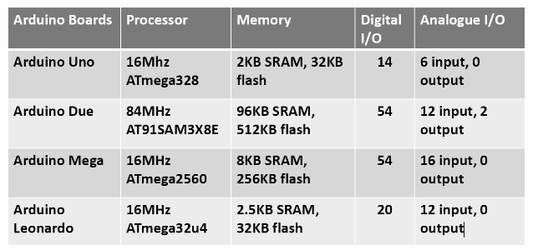

**Arduino Shields:**  Shields are boards that can be plugged on top of the arduino PCB extending its capabilities. Those are pre built circuit boards, used to connect to a number of Arduino Boards.

It provides additional capabilities like connecting Internet, Motor Controlling, Wireless communication, LCD screen etc.

> Ethernet Shield - Connect to Internet

> Relay Shield - Control High Voltage.

> Proto Shield - prototyping shield, makes easy to prototype.(easy for custom circuits)

> Motor Shield - control of motor direction and speed.

> LCD Shield - easy to use 16x2 Character LCD

> Capacitive Touchpad Shield - simple capacitive touch interfaces.

> Smoke Detector - detect concentrations of combustible gas in the air.

> 64-Button Shield - connect upto 64 buttons.

> Joystick Shield kit - simple analog inputs and 4-separate buttons and 1 button under the joystick.

> GSM/GPRS Shield - Connect to GSM/GPRS cell phone network.

> GPS Logger Shield - access to a GPS module, micro SD memory card socket and other peripherals for position-tracking, speed-monitoring, altitude-observing wonder logger.

> Wireless SD Shield - Communicate wirelessly using a wireless module.

> CC300 WiFi - self-contained wireless network processor that incorporates internet connectivity.

**Lecture -03**

**Variable Scope**

int id=10; // global variable

void setup() {

}

int function(int x){ // x is formal scope

return x+1;

}

void loop() {

// put your main code here, to run repeatedly:

int dhaka;

dhaka = id; //local variable

int ans;

ans=function(dhaka);

Serial.println(ans);

delay(5000);

}

**Operator**

Right Shift >> [ remove last bit] A=6; A>>2; -> 1

Left Shift << [ add 0 in last position ] A=6; A<<2; A->24

Binary Not (~A) [ do one’s complement]

Compound bitwise OR ( |= )

Compound bitwise AND ( &= )

**Lecture -04 & 05**

Normal Conditional statement

#-Switch Case-#

max= (a>b) ? a : b;

If the condition is true then a, otherwise b.

Normal loops.

analogWrite(Pin Number, PWN value);

void loop() {

// fade in from min to max in increments of 5 points:

for (int fadeValue = 0 ; fadeValue <= 255; fadeValue += 5) {

// sets the value (range from 0 to 255):

analogWrite(ledPin, fadeValue);

// wait for 30 milliseconds to see the dimming effect

delay(30);

}

// fade out from max to min in increments of 5 points:

for (int fadeValue = 255 ; fadeValue >= 0; fadeValue -= 5) {

// sets the value (range from 0 to 255):

analogWrite(ledPin, fadeValue);

// wait for 30 milliseconds to see the dimming effect

delay(30);

}

}

float avg(int x, int y, int z){

return (x+y+z)/3;

}

void setup() {

// put your setup code here, to run once:

Serial.begin(9600); //opens the serial Port

}

void loop() {

// put your main code here, to run repeatedly:

int x=5, y=7, z=9;

Serial.println(avg(x,y,z),4);

}